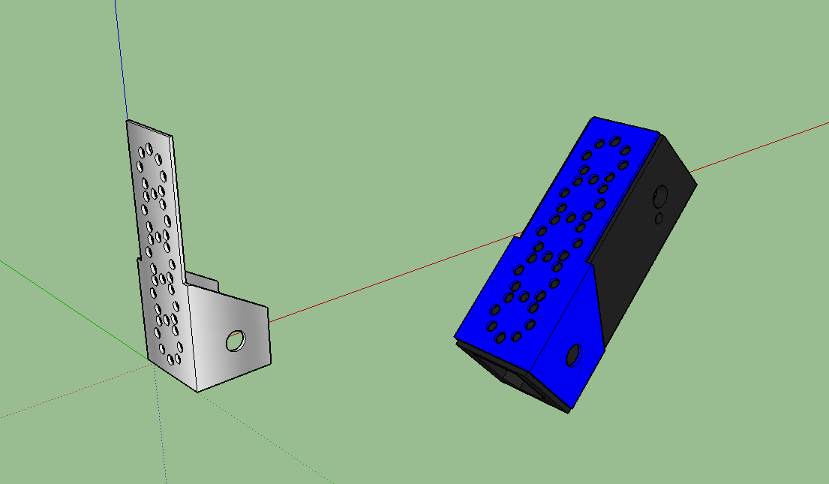

Khan's log
Star date 11/27/14
Happy Thanksgiving! This past week of break has given us the time we needed to put the finishing touches on the robot. We have also now had the time to make a claw system for grabbing on to the rolling goals. It is a simple pair of pegs that are rotated down by a servo to capture the base of the rolling goal. We also finished integrating our light system.

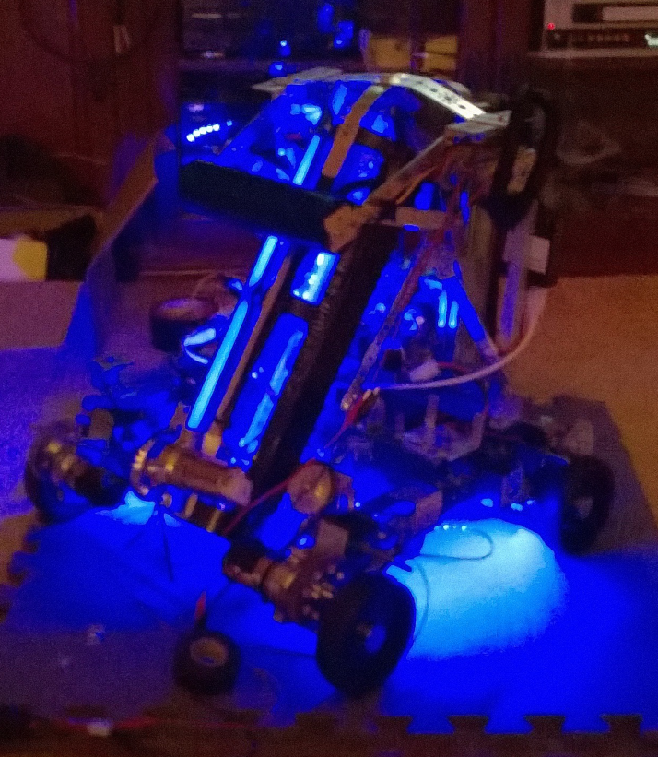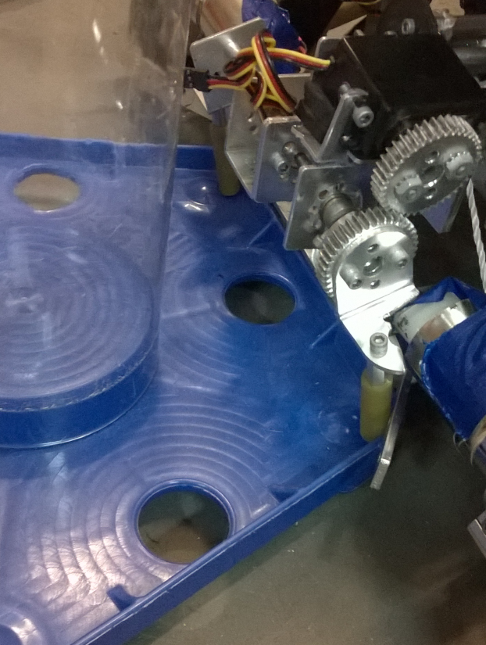

Khan's log
Star date 12/6/14
Today two of our team members went to watch our sister team (452 PHI Alpha) compete in Monrovia CA. While there we had the opportunity to scout out other teams designs and gain some lessons learned without having to compete. We gathered a wealth of useful information and also were able to offer assistance to several teams that were in need of help. We also where able to see what designs worked well and what designs did not. After the day of scouting and compiling designs, we have come to a realization that our robot needs some dramatic changes.
- Our intake needs to be way more reliable.
- Our lift mechanism needs to be able to reach the center endgame goal reliably.
- Our output end needs to have some device to stop the balls from rolling over the mouth of the tube.
We also made an observation that several teams were getting their wheels hung up inside the rolling goals bases. Our suspension however can drive right over these bases with no such problem.
After some further design revision and brainstorming, we have worked out a concept design of what we would like our robot to work and look like.
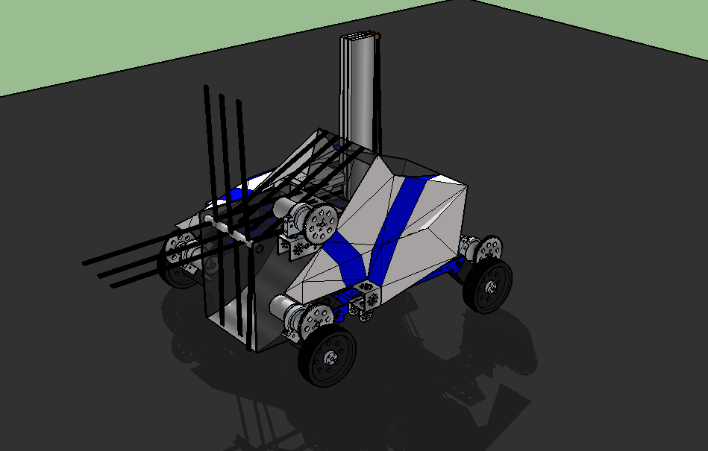
Our sister team 452 PHI Alpha was also kind enough to give us a copy of their lessons learned from the Monrovia competition.
